User Acceptance Testing (UAT) Template
Date | 28 June 2025
Team ID | LTVIP2026TMIDS24889
Project Name | Educational Organisation Using ServiceNow
Maximum Marks

Project Overview:
Project Name: Educational Organisation Using ServiceNow
Project Description: This project digitizes and automates processes within an educational institution, including student registration, faculty details, course management, and helpdesk ticketing using ServiceNow’s low-code platform.
Project Version: 1.0
Testing Period: June 15, 2025 – June 25, 2025
Testing Scope:
Features and Functionalities:
- Student Registration
- Faculty Management
- Course Module
- Helpdesk Ticket Submission
- Admin Dashboard
User Stories to be Tested:
- Students can register successfully with valid details.
- Faculty members can manage their course details.
- Admins can view and monitor dashboard data.
- Users can raise tickets with issue details
Testing Environment:
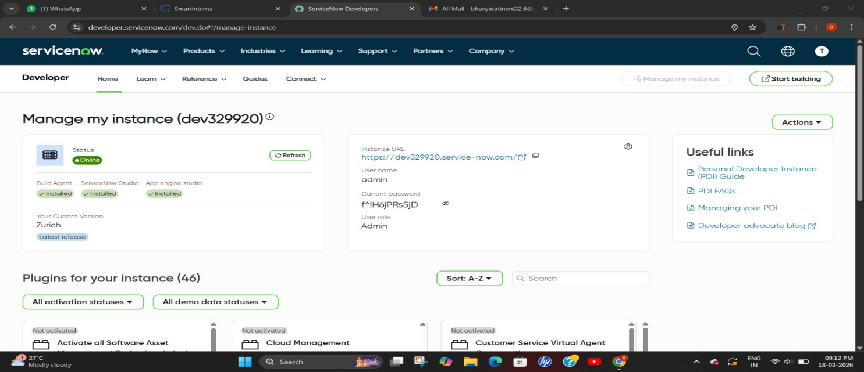
Test Cases:
Test Case ID | Test Scenario | Test Steps | Expected Result | Actual Result | Pass/Fail
TC-001 | Student Registration | 1. Open registration form  2. Enter valid details  3. Click Submit | Success message shown and data stored | Registration successful | ✅ Pass
TC-002 | Ticket Submission (Negative Test) | 1. Navigate to ticket form  2. Leave mandatory fields empty  3. Click Submit | Error messages displayed for required fields | Validation errors appeared | ✅ Pass
TC-003 | Faculty Dashboard View | 1. Login as faculty  2. Open courses module | Assigned courses are displayed correctly | Courses listed accurately | ✅ Pass
TC-004 | Admin Dashboard Overview | 1. Login as admin  2. Access dashboard | Overview with stats (students, tickets) is shown correctly | Dashboard loaded successfully | ✅ Pass

Bug Tracking:
Bug ID | Bug Description | Steps to reproduce | Severity | Status | Additional feedback
BG-001 | Submit button not responsive on mobile | 1. Open registration form on mobile  2. Enter data  3. Tap Submit | Medium | In Progress | Requires mobile compatibility check
BG-002 | Dashboard not refreshing | 1. Register new student  2. Navigate to board | High | Open | May need auto-refresh mechanism

Sign-off:
Tester Name: K Dinakar
Date: Jan 25 2025
Signature: Dinakar
Notes:
- ✅ All core and edge scenarios have been covered.
- 🐞 Bugs have been documented with clear reproduction steps and severity levels.
- 🔐 User roles were tested with proper access control.
- 🚀 Final approval from the project manager is required before deployment.

